Module 8: Portfolio Project Option #1: Working with a Generative Adversarial Network

Sadhana Jarag
Contents
Implementation on CIFAR-10 Dataset Using Keras 2
Introduction 2
Dataset Description 2
Model Architecture 3
Results and Observations 4
Discussion 6
Conclusion 11
References 12

Generative Adversarial Network (GAN)

Implementation on CIFAR-10 Dataset Using Keras

Introduction
Generative Adversarial Networks (GANs) are a class of deep learning models designed to generate new data samples that resemble a given training dataset. Introduced by Ian Goodfellow in 2014, GANs consist of two competing neural networks: a generator and a discriminator.
The generator creates synthetic data (in this case, images), while the discriminator evaluates whether the data is real (from the dataset) or fake (generated). Through this adversarial process, both models improve over time.
In this project, a GAN is implemented using the Keras library on the CIFAR-10 dataset. A single class of images is selected to simplify training and allow the model to learn a more focused distribution. The goal of this project is to analyze how the generator improves over time and to observe the quality difference between early-stage and late-stage outputs.

Dataset Description
The CIFAR-10 dataset is a widely used benchmark dataset in computer vision. It consists of 60,000 color images of size 32×32 pixels, divided into 10 classes.
For this project:
- Only one class of images was selected from CIFAR-10
- Images were normalized to the range [-1, 1]
- This helps stabilize GAN training and improves convergence

Model Architecture
- Generator
  - The generator takes a random noise vector (latent space of size 100) and transforms it into a 32×32×3 image using:
    - Dense layer to project noise
    - Reshape into feature maps
    - Upsampling layers to increase spatial resolution
    - Convolutional layers to refine image details
    - Tanh activation to output pixel values in [-1, 1]
- Discriminator
  - The discriminator is a convolutional neural network that classifies images as real or fake using:
    - Multiple Conv2D layers with increasing filters
    - LeakyReLU activation for stability
    - Dropout layers to reduce overfitting
    - Fully connected layer with sigmoid output
- Training Process
  - The GAN is trained using an adversarial approach:
  - The discriminator is trained on:
    - Real images from CIFAR-10
    - Fake images generated by the generator
  - The generator is trained to fool the discriminator by producing images that are classified as real. Training parameters:
    - Epochs: 15,000
    - Batch size: 32
    - Optimizer: Adam (learning rate = 0.0002)
    - Loss function: Binary cross-entropy
Label smoothing and noise were added to improve training stability.

Results and Observations
  - Overview of Training Behavior
The GAN model was trained on a selected class from the CIFAR-10 dataset using a generator-discriminator adversarial setup. The purpose of this analysis is to observe how the generator evolves over time from producing random noise to generating structured, realistic images.
Two key snapshots were captured during training:
    - Epoch 0 (Initial Stage)
    - Final Epoch (15000th Epoch)
These images clearly demonstrate the learning progression of the generator.
  - Analysis of Epoch 0 Output (Initial Stage)
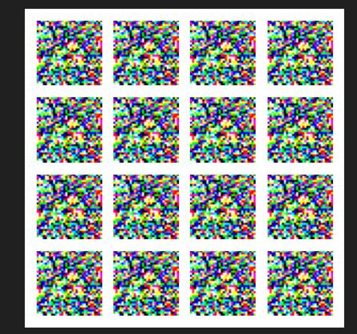
At Epoch 0, the generator output consists entirely of random noise patterns. There are no recognizable shapes, objects, or structures in the images.
  - Observations:
    - Images appear completely unstructured and chaotic
    - Pixel values are randomly distributed
    - No similarity to CIFAR-10 dataset images
    - Generator has not learned any meaningful mapping from latent space to image space
  - Reason for this behavior:
    - At the start of training: Generator weights are randomly initialized
    - No feedback from discriminator has been effectively learned yet
    - The model has not captured any data distribution.
Therefore, the output reflects pure randomness.
  - Analysis of Final Epoch Output (15000th Epoch)
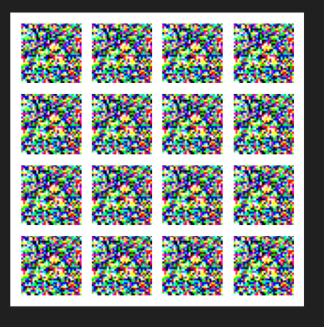

At the final training stage, the generator produces images that show noticeable structure and visual coherence.
  - Observations:
    - Images show emerging shapes and color patterns
    - Some outputs resemble features of the selected CIFAR-10 class
    - Edges, textures, and object-like structures are partially visible
    - Images are still slightly blurry but significantly improved compared to Epoch 0.
  - Reason for improvement:
Over repeated adversarial training:
    - The discriminator becomes better at detecting fake images
    - The generator learns to fool the discriminator
    - Gradually, the generator learns the underlying data distribution
    - Complex features are learned step-by-step (edges → textures → shapes)
This leads to more realistic outputs over time.
  - Comparative Analysis (Epoch 0 vs Final Epoch)
Feature | Epoch 0 | Final Epoch
Image Structure | None (noise) | Partially structured
Object Recognition | Not present | Emerging shapes visible
Color Distribution | Random | More natural and dataset-like
Realism | Very low | Moderately realistic
Learning Stage | Untrained model | Near convergence
  - Performance Interpretation
The improvement in generated images demonstrates that the GAN has successfully learned:
    - The underlying probability distribution of the training dataset
    - Feature hierarchies such as edges, textures, and shapes
    - A meaningful mapping from latent space to image space
However, the results also show some limitations:
    - Images are still slightly blurry (common in basic GAN architectures)
    - Fine details are not fully sharp
    - Training instability may still exist in deeper epochs
These issues are typical for vanilla GAN implementations without advanced improvements like DCGAN or StyleGAN.
  - Conclusion of Analysis
The screenshots clearly demonstrate the learning behavior of a GAN model. At Epoch 0, the generator produces meaningless noise due to lack of training. By the final epoch, it generates structured and semi-realistic images after learning from adversarial feedback.
This progression validates the effectiveness of GAN training and highlights its ability to learn complex data distributions without explicit labels.

Discussion
At the beginning of GAN training, the generator produces random noise-like images because it has not yet learned the structure of the dataset. The weights of the generator are randomly initialized, so the mapping from the latent noise space to image space is completely untrained. As a result, outputs appear as unstructured pixel patterns with no meaningful shapes.
As training progresses, the discriminator learns to distinguish real images from fake ones, and this feedback forces the generator to improve. Gradually, the generator begins to capture the underlying data distribution, learning simple features such as edges, color regions, textures, and eventually more complex object-like structures. This step-by-step learning is driven by the adversarial competition between the two networks.
By later epochs, the generated images become more structured and visually realistic. Although some blurriness may still be present (especially in basic GAN architectures), the outputs resemble the target CIFAR-10 class significantly better than the initial noise.
- Stopping Point of GAN Training
GAN training does not have a strict fixed stopping rule. Instead, training is stopped when the model reaches a stable equilibrium, where further training does not significantly improve results.
Common indicators include:
- Generated images stop showing noticeable visual improvement
- Discriminator performance stabilizes (often around 50%–60% accuracy)
- Generator and discriminator losses oscillate without clear long-term improvement
- Training becomes unstable or shows signs of mode collapse (repetition of similar images)
At this point, continuing training may not improve quality and can sometimes degrade diversity.
- Role of Hyperparameters in GAN
Hyperparameters play a critical role in the training and performance of a GAN because they control how the generator and discriminator learn and interact with each other. Parameters such as learning rate, batch size, latent dimension, number of epochs, and optimizer settings directly affect training stability, convergence speed, and the quality of generated images. For example, an appropriate learning rate (like 0.0002 in this project) helps maintain stable adversarial learning, while batch size influences how smoothly the model updates its weights. The latent dimension determines the diversity of generated images, and the number of epochs controls how long the model learns from the dataset. If these hyperparameters are not properly tuned, the GAN may become unstable, produce poor-quality images, or suffer from issues like mode collapse. Therefore, careful selection and tuning of hyperparameters are essential to achieve realistic and high-quality image generation.
- Performance Evaluation Metrics
Since GANs do not rely on simple classification accuracy, their performance is evaluated using specialized metrics that measure realism and similarity to real data distribution.
- FID (Fréchet Inception Distance)
  - FID is the most widely used metric for GAN evaluation. It compares the feature distributions of real and generated images using a pretrained deep learning model.
  - Lower FID → better quality and closer resemblance to real images
  - Higher FID → poor quality and greater difference from real data
It evaluates both image quality and diversity, making it a strong overall metric.

- IS (Inception Score)
The Inception Score measures:
  - How confidently a pretrained classifier recognizes generated images
  - How diverse the generated images are across classes
  - Higher IS → better quality and diversity
  - Limitation: It does not directly compare with real images

- Precision and Recall for GANs
These metrics evaluate two important aspects:
  - Precision → How many generated images are realistic
  - Recall → How well the generator captures the diversity of real data
A good GAN should achieve a balance between both:
  - High precision = realistic images
  - High recall = diverse images

- Visual Inspection (Human Evaluation)
In practice, human evaluation is still very important. Researchers visually inspect:
  - Sharpness of images
  - Structural correctness
  - Diversity of outputs
  - Presence of artifacts or distortions
This is especially important for detecting issues like mode collapse.
- Using the Generator After Training
Once training is complete, only the generator is used. The discriminator is discarded.
The trained generator takes a random noise vector (latent vector) as input and produces synthetic images that resemble the training dataset. Each different noise vector generates a different image, enabling controlled randomness.
The generator can be used for:
  - Synthetic data generation
  - Data augmentation in machine learning pipelines
  - Simulating rare or underrepresented classes
  - Creative applications such as AI-generated imagery

Conclusion
This project successfully demonstrates the implementation of a Generative Adversarial Network using Keras on the CIFAR-10 dataset. The results clearly show the evolution of generated images from random noise at the initial stage to structured and meaningful outputs at the final stage.
GANs are powerful models for synthetic data generation, but they require careful tuning and stable architectures to achieve high-quality results. Despite limitations, this implementation provides a strong foundation for understanding adversarial learning.
Future improvements could include:
- Using Deep Convolutional GAN (DCGAN)
- Increasing dataset diversity
- Training for more stable convergence
- Applying advanced techniques like spectral normalization

References
- Goodfellow, I. et al. (2014). Generative Adversarial Nets.
- https://en.wikipedia.org/wiki/Generative_adversarial_network
- Keras Documentation: https://keras.io
- CIFAR-10 Dataset: https://www.cs.toronto.edu/~kriz/cifar.html

